**Trinidad and Tobago Doubles**

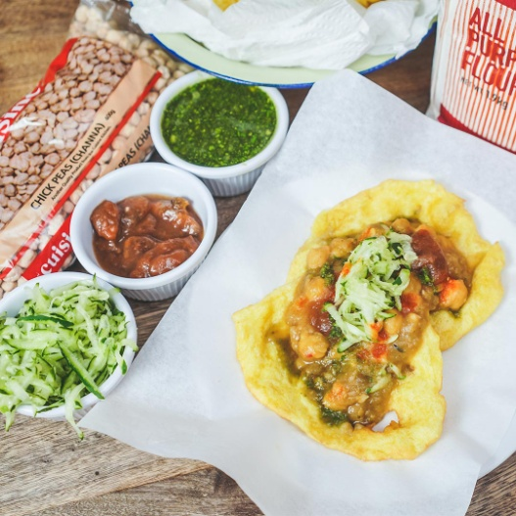

**INGREDIENTS**

**Doubles Bara**

* 2 cups [all purpose flour](https://amzn.to/34aeGlT)
* 1/2 teaspoon [baking powder](https://amzn.to/2D6v3V2) preferably aluminum free
* 1 teaspoon [salt](https://amzn.to/37sGeoL)
* 1 teaspoon [instant yeast](https://amzn.to/337OJ5h)
* Pinch [turmeric](https://amzn.to/2roy0NK) 1/4 tsp
* 2 teaspoons [sugar](https://amzn.to/334rxow)
* 1 cup lukewarm water lukewarm, MINUS about 3 tbs
* 1 tablespoon [vegetable oil](https://amzn.to/2qFB8F2) for rubbing on dough
* 2 cups [vegetable oil](https://amzn.to/2qFB8F2) for frying

**Doubles Channa Recipe**

* 1/2 lb [dried chickpeas](https://amzn.to/34iH7hG) channa
* 1 teaspoon [baking soda](https://amzn.to/2rt223i) divided
* 1 tablespoon [minced culantro](https://amzn.to/2OJCBlP) bandhania
* 1 tablespoon [garlic](https://amzn.to/2OiDUcB) minced (3 cloves)
* 1/8 teaspoon [turmeric](https://amzn.to/2roy0NK) or up to 1 tsp depending on the brand
* 1 1/2 tsp bandhania finely chopped or minced--about 3 leaves
* 1/2 teaspoon [amchar massala](https://amzn.to/37ABRbj" \t "_blank) or ground roasted cumin, or a combo
* 1-2 teaspoons [Himalayan Salt](https://amzn.to/2ypoE8b) Add to taste

**Cucumber Chutney**

* 1 cucumber grated
* 1 tsp minced garlic
* [hot pepper,](https://amzn.to/2XGqSsl)minced, to taste
* 1 tsp bandhania minced
* [salt](https://amzn.to/37sGeoL) to taste

**Bandhania Chutney**

* 1 bunch bandhania (shado beni or culantro)
* 2 cloves [garlic](https://amzn.to/2OiDUcB)
* [hot pepper](https://amzn.to/2XGqSsl) to taste
* [salt](https://amzn.to/37sGeoL) to taste

[**US Customary**](https://cookingwithria.com/2018/12/how-to-make-trinidad-doubles-detailed-recipe-instructions.html) - [Metric](https://cookingwithria.com/2018/12/how-to-make-trinidad-doubles-detailed-recipe-instructions.html)

**METHODS**

**Bara Instructions**

1. In a medium bowl, add flour, baking powder, salt, yeast, turmeric and sugar.
2. Add lukewarm water gradually and mix to form a very soft, slightlysticky dough. Do not over knead.
3. Rub the dough with oil, cover and set aside to rest 1 hour (minimum) or until doubled(max 6 hrs or overnight). The longer it rests, the softer the bara--6 hours is perfect, but if you are in a hurry, 1 hr can work
4. Divide the dough into 16 balls. Cover and allow it to raise another hour or until doubled.
5. Rub oil on a flat surface or plate. Place the dough on the oiled surface and flatten to a 6 inch round(oil hands as well) or almost transparent!! Make to your desired thickness and width--keeping in mind it puffs up as it cooks
6. Meanwhile heat oil in a small pot over medium-high heat. When the oil is very hot, gently place dough in hot oil and fry on each side until cooked and golden brown--takes seconds if the oil is hot enough. Drain on the side of the pot, using the spoon.
7. **lace the fried dough (bara) in paper towel or clean kitchen towel, stacking them on each other as they are done frying. This will allow them to flatten, steam and give them the soft, chewy texture we all love--just like the doubles man's!** **Repeat with the remaining dough.** Serve hot with Doubles.

**Channa Instructions**

1. Soak chickpeas overnight with 1/2 teaspoon baking soda. Drain and rinse with several changes of water. Drain again.
2. In a pot, add about 6 cups of water and place over medium heat. Add channa, 1 teaspoon of salt, 1/2 teaspoon baking soda and stir to combine. Bring to a boil and scoop out any impurities that rise to the top. Adding more baking soda than this will give it a weird metallic--bakign powder taste.
3. When chickpeas are tender, about 1 hour, add minced bandhania, minced garlic and turmeric and mix well. You can also add minced hot pepper.
4. Continue to cook for 15-20 minutes or longer if required. During this time, with a wooden spoon, stir, moving back and forth motion to bring it to the right consistency. This will take several minutes for the channa to thicken, so be patient. Doubles will be ready soon!
5. Taste for salt and add more if required. To finish, mix in bandhania, amchar massala or ground roasted cumin or a combination.
6. Enjoy with the baras! Can be made ahead--a day before. Can be easily doubled.

**Chutney**

1. To make the cucumber chutney, mix all ingredients to combine. Taste and add salt and black pepper if required.
2. To make the bandhania chutney, place all ingredients in a blender or food processor and pulse to combine. Add salt to your preference. You will need to add water if making it in a blender--just enough to combine,

TRINIDAD DOUBLES | STEP BY STEP VIDEO: <https://www.youtube.com/watch?v=J1l4ujeiRTc>